Mama Air. “Breathe Safely for Your Baby”. Download Mama Air

SW and FR активны почему-то, они нужны, но их нужно заглушить.
«More than 1.000 professionals support» - заменить текст в баннере здесь и ниже
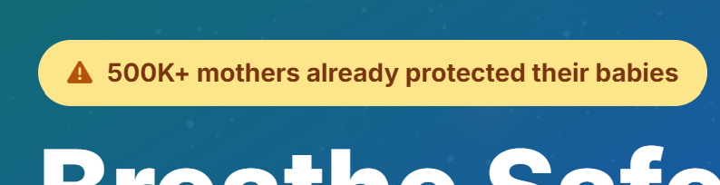
Mama Air is personal behaviour companion, empowering mothers to navigate pregnancy safely with the air quality around them.  Этот текст вообще не использован. А именно этот текст иконку справа нужно применить. | 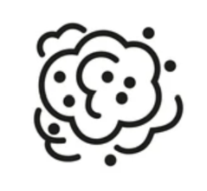
Because the air you breathe shapes the life you carry.
Кнопка оранжевого цвета – никакого красного! ))
Синий фильтр с этого блока снять, все размещать прямо на изображении.
Скриншот заменить на реальный мобайл – предоставлю.

Весь этот блок нужно дать, так как здесь написано и размещено, не разбивая на разные блоки.
Why Choose Mama Air
Environmental risks like air pollution and heat stress can silently impact your well-being and your baby's development.
With Mama Air, you stay informed and protected - anytime, anywhere:
✅ Air pollution aware and alerts tailored to your location
✅ Personalized recommendations to reduce health risks
✅ Symptom tracking with insights designed for pregnancy
✅ Supportive advice, empowering you to make safe choices
Every mother deserves a safe environment - Mama Air helps make that possible.

Весь этот блок нужно дать, так как здесь написано и размещено.
Learn How It Works
Mama Air combines advanced mobile technology with intelligent cloud analytics to support your pregnancy  Да, эти 3 блока можно разместить раздельно в горизонтали  - You use the Mama Air app to track your timeline, symptoms, daily exposure, and receive alerts.  - Secure cloud platform powered by DIAQNOSTIC ** processes your data with environmental health and mother care expertise.  - You get personalized guidance on behaviour, safe movement, nutrition, supplements, work and sport loads, household and living.  That all help you avoid harmful air conditions, manage fatigue, and protect your pregnancy. | 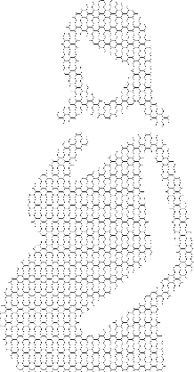

**DIAQNOSTIC analytics (https://diaqnostic.com/) is built with leading maternal health research and environmental risk detection, tailored adapted to the realities of each region of the world, local medical practice, diets and traditions.

В этом блоке нужно заменить всё, потому что мы обсуждали, что у нас НЕТ пользователей, поэтому мы можем дать мнения профессионалов об актуальности решения.
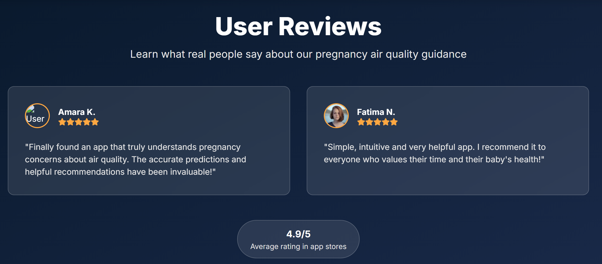
Leaders Supports
Learn how opinion leaders endorse our approach.

Francine Yao Fu (Australia). Master of Public Health | Public Health Researcher | Community Health
“What you are doing is very meaningful to the women's community and empowering women's health. I am very impressed.”
Natalie D. Hanson, Ph.D (Chicago, US). Driving innovation & growth in Women's Health
“I think your approach of the intersection of climate issue and femtech is an interesting one!”
Barun Aggarwal (Delhi, India). Founder BreatheEasy | WELL AP, RESET AP | Global IAQ Leader
“Thats a great product...much needed in many parts of the world.
We should collaborate on helping the to-be moms breathe better air!”
Lisa Maria Madera (Pichincha, Ecuador). Mother, Educator, Community weaver. Climate Parent Fellow 2024.
“Your work sounds really interesting and important. I am really interested in applying diagnostic environmental tools and how we might leverage that information to create safer environments for our children as we face the challenges of climate change and environmental degradation.”
Laura Spence (Sheffield, UK). Midwife. Educator. Advocate. | Founder of NeuroNatal
“Your work sounds fascinating and so important. The impact of environmental factors like air pollution on maternal and fetal health is still so under-discussed, yet hugely significant.”
Dr. Mories Atoki (Lagos, Nigeria). CEO - ABCHealth l Board Director I Health & Education Advocate
“Personalized environmental risk tracking… what you do sounds amazing!”
Sosthenes (Elias) Bagumhe (Dodoma Tanzania). Gen. Secretary of Pan African Health Informatics Association (HELINA)
“I am actually very interested in you approach”
Phyllis (Muriuki) Kiburi (Nairobi, Kenia). Maternal-Child Health | Environmental & Public health
“It is impressive to see how DIAQNOSTIC translates complex air quality data into personalised health recommendations. I am very impressed with the Mama Air app's focus on supporting African women in real high-risk environments.”
Moono Kawayo (Nairobi, Kenia). Digital/Public Health | Mandela Washington Fellow2024 and Climate Change
“Good to hear how you are utilizing AI and digital health interventions for solve public Health challenges”
Тут, наверное, должен быть скроллинг горизонтальный.
Блока с «оценками» тоже пока быть не должно. После Beta-version, когда будет >10.000 установок переделаем в этот вид обратно

Get Mama Air for Android
Your health breath journey starts here. Download Mama Air on your Android device.
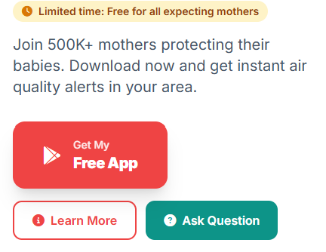
Откуда это всё? – Все эти кнопки «Learn more» and “Ask…” – убираем
Про 500k+ и т.д. убираем везде
Download Mama Air
Available for Sub-Saharan regions. iOS version coming soon.
Кнопка оранжевого цвета – никакого красного! ))
Убиваем полностью блок ниже.
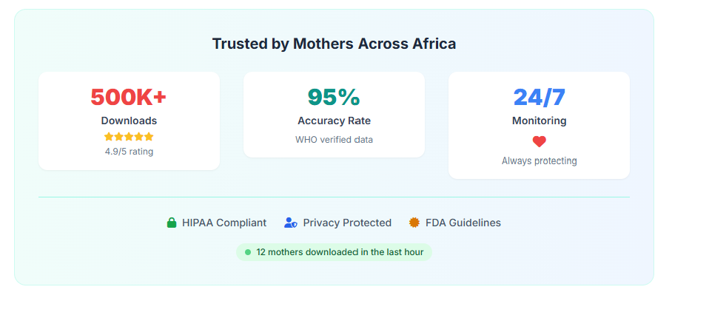
Убиваем полностью блок ниже.
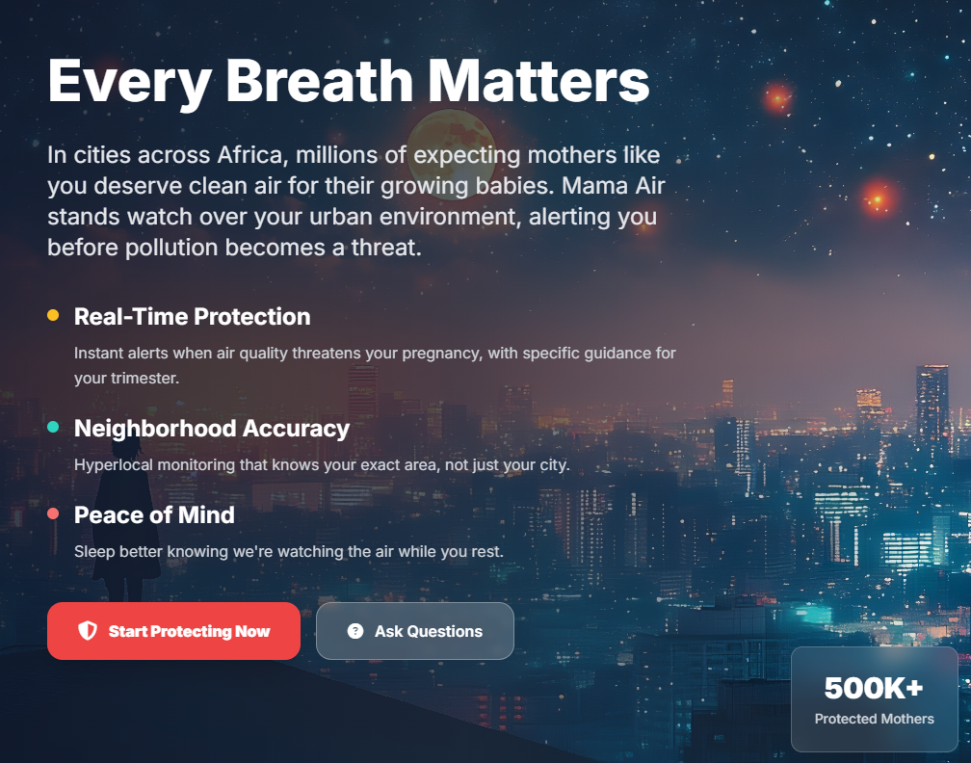

В этом блоке все иконки должны быть одного цвета – зеленого
Все 4 документа нужно взять по этой ссылке. Их нужно дать просматривать целиком, а это не по 2 строчки текста.
https://docs.google.com/document/d/1MUGr84-PWu7NBDjbVv4k8aUzEgI15IG6yxMI-ZpDRWs/edit?usp=sharing
‘Mama Air’ Policies
We care about transparency and your peace of mind:
- Medical Disclaimer — Mama Air is a supportive recommendation tool and not a replace, but support professional medical care.
- Customer Happiness — We’re committed to your satisfaction and continuous improvement.
- App Privacy Policy — Your personal and health information is handled with strict confidentiality.
- Website Privacy Policy — We respect your privacy while you browse or interact with our site.

For now, everything accessible in English. In 2025 later: French/Swahili.

Contact Us - We Value Your Voice
We welcome your feedback as we continuously improve our app to best support our users.
Please share your thoughts on app features or any other ideas and suggestions using the feedback form here or by sending us an email at support@mamaair.app.
Together, we create a healthier tomorrow for mothers and babies across world.

Не требуется галлюцинаций и улучшений. Я предупреждал, что текст выверен доктором
Этот блок тоже убить!
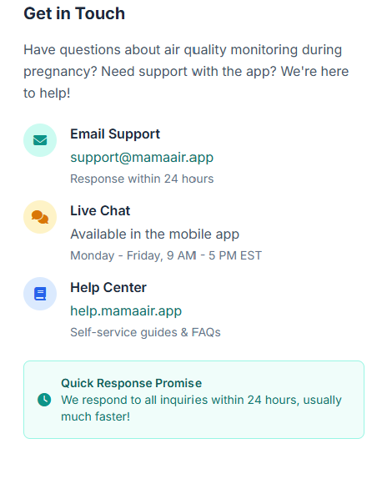

Footer
Breathe with Confidence. Act with Support. Mama Air.
Copyright 2025
Все, что ниже – все убить!


